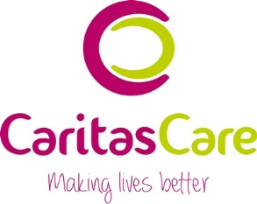

Best Support Award 2017/18 Nomination Form

I would like this person to win this award:  This is the name of the service they work in:  Please the relevant award: |  |  | Name(s)  Service:  Children’s Services Award (which includes Adoption, Foster Care, Concurrent Planning, CFAS)  Community Services Award (which includes Supported Living, FX, VIP, React, ACE, Vincent House, Plungington Community Centre)
I nominate the above for this award because:
Please choose the top 3 reasons why you want this person to win an award. Please tick in the box below
they provide me and/or my child with an excellent professional, supportive service
I know they will do their best to support me and/or my child
I can rely on them
they help to keep me, my family and/or child safe
they do what they say they will do
they show dignity and respect at all times
they offer choices and involve me in making my own decisions
they listen to me and respond in a sensitive, appropriate manner
they support me and/or my child to achieve what I set out to do
Please tell us how this person has supported you in the choices you have given above. Give our judges as much information as you can. Please do not name anyone else as they may not wish you to share information about them.
1
2
3
Your name |  |  |  | I do not want to give my name

Please return your nominations to:

Email to nominations@caritascare.org.uk. Please put BEST SUPPORT AWARD in the subject header.

Post to Amanda Forshaw, Caritas Care, 218 Tulketh Road, Preston PR2 1ES. Please write BEST SUPPORT AWARD in the bottom left hand corner of the envelope. If possible, please arrange hand delivery.

